A000-AFR-Congo-Songye Kifwebe-Mask-Wood-Blackened-early 20th c

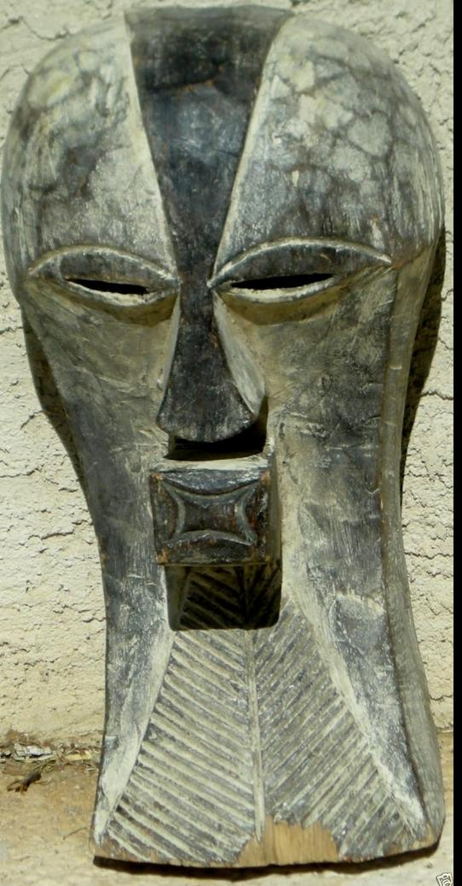

Case No.: 6

Accession No.

Formal Label: Congo-Songye Kifwebe-Mask-Wood-Blackened-early 20th c

**Display Description:**

A large Songye Kifwebe mask.  The mask is a classic Kifwebe stylized mask with a sagittal crest, protruding eyes, nose and quadrangular mouth.  Incised lines throughout with black and white pigmentation.  Raffia holes at sides.

Male **Bukishi** associations, clouded in secrecy, yielded political and mystical power revealed through their masks, known as **Kifwebe** (singular) and **Bifwebe** (plural). Female masks, primarily white, are restrained and elegant with striated surfaces. Their function was to awaken and honor benevolent spirits. Male masks, known for their distinctive exaggerated forms, are also well represented. Aggressively formed with bulging eyes, projecting mouths and powerful crests, the masks of elders embody the greatest potential and strength. The dynamic forms symbolize the level of power, or grade of the masked figure. Used for social control, political action, or the solicitation of contributions and protection, they were danced at important funerals, visits and investitures

Accession Number:

**LC Classification:**

Date or Time Horizon: **Early 20th Century**

Geographical Area: **Congo (D.R.C.)**

**Map:**

**GPS coordinates:**

Cultural Affiliation: **Songye**

Media: **Wood/Pigmentation**

Dimensions: H 15 in

Weight: **7 oz**

Condition:

Provenance:

**Discussion:**

**References:**